Phase 8: Data Management & Deployment

1. Introduction
Phase 8 focuses on data management, deployment, and version control in Salesforce. The goal is to ensure that data and metadata are consistent across orgs, deployments are successful, and test data is available for integration and functionality testing.
Objectives:
- Deploy Apex classes and metadata to the DevOrg.
- Create test data for integration and REST API testing.
- Understand and use VS Code & Salesforce CLI (SFDX) for deployment and execution.
- Manage data via Data Import Wizard and understand duplicate prevention.

Data Import Wizard – Step-by-Step Implementation
The Data Import Wizard was used in Phase 8 to bulk load product data into Salesforce in a guided, admin-friendly way. This ensured that our Products object was populated with clean, structured data for later use in reports and dashboards.

1. Prepare the CSV File
- Create a CSV file with the following columns:
  - Product Name
  - Product Code (SKU)
  - Price
  - Description
- Save the file as Products_Import.csv.
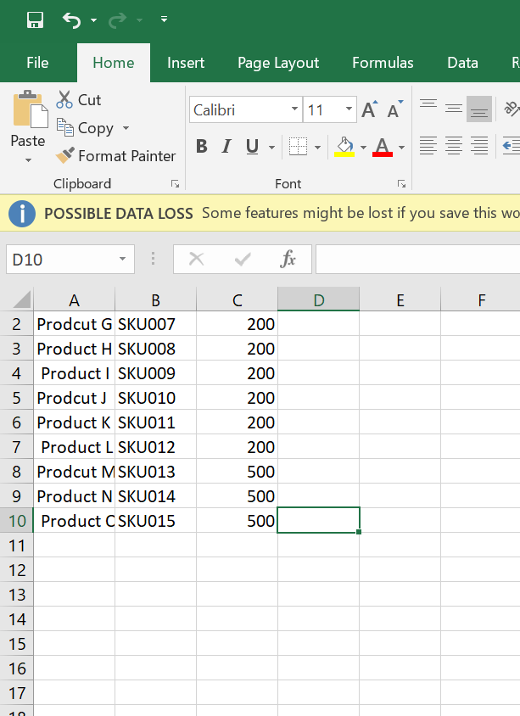

Launch Data Import Wizard
- Go to Setup (gear icon → Setup).
- In the Quick Find box, type Data Import Wizard.
- Click Data Import Wizard from the search results.
- Click Launch Wizard.
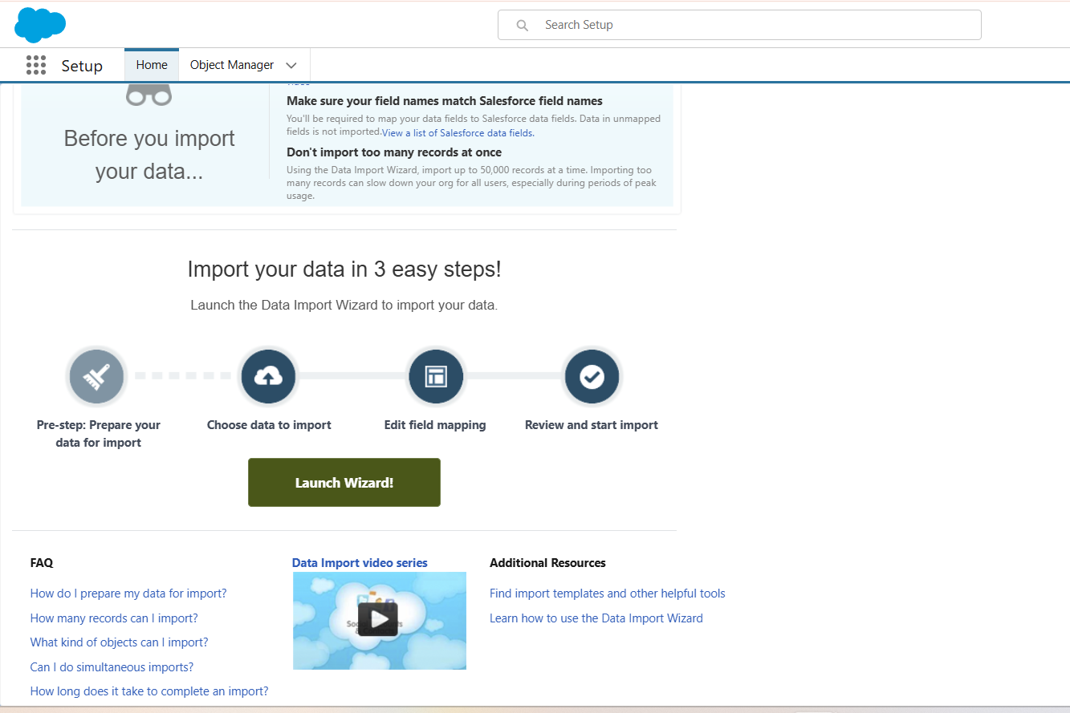

Choose the Object
- Under the Standard Objects or Custom Objects section, select Products (or Product__c if using custom).
- Click Add New Records (since we are inserting products for the first time).
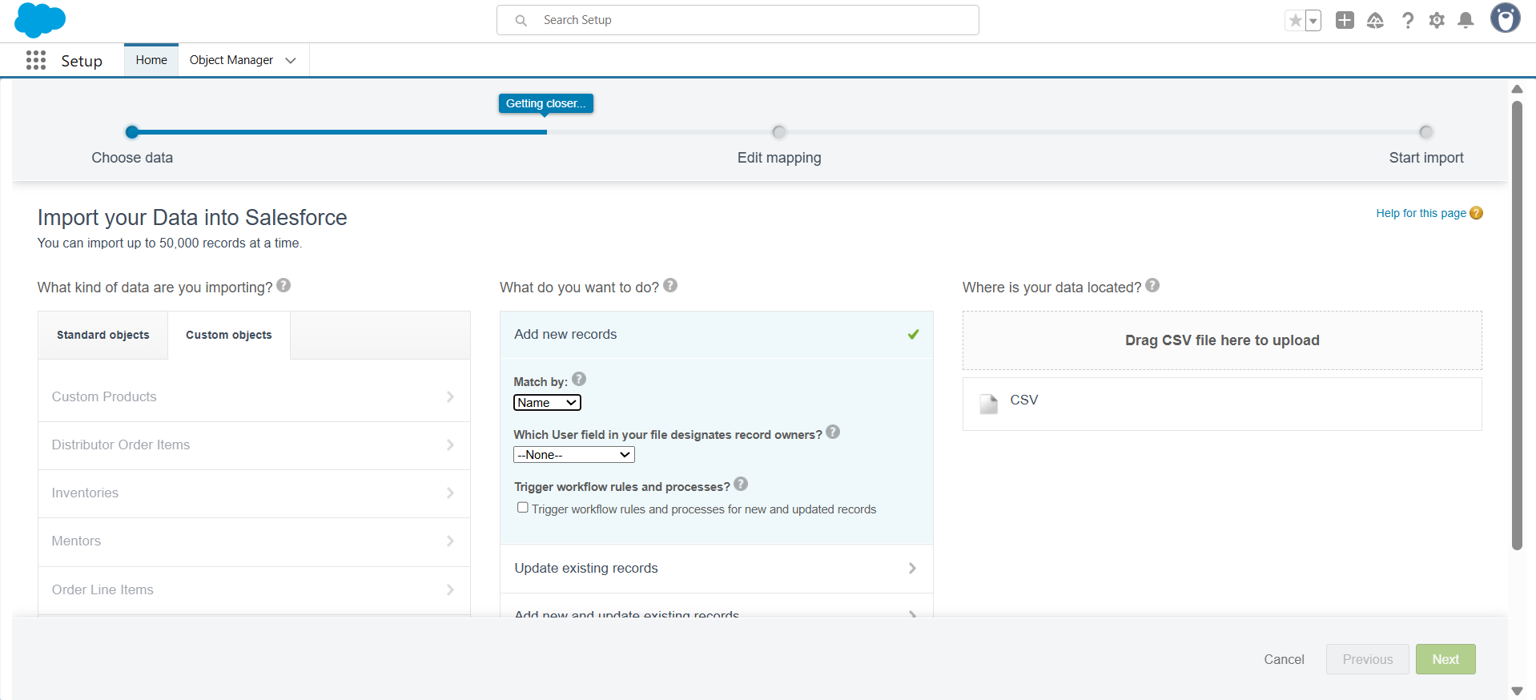

Upload the CSV File
- Click Choose a CSV File → upload Products_Import.csv.
- Click Next.
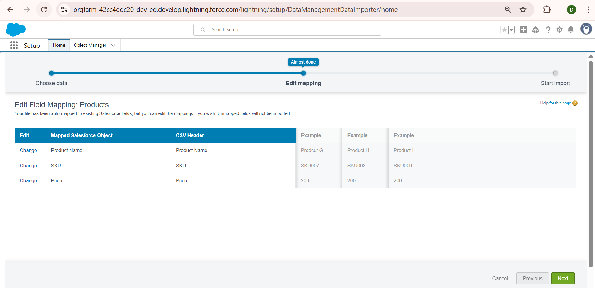

Field Mapping
- The wizard auto-maps most fields; verify mappings:
  - Product Name → Product Name
  - Product Code (SKU) → Product Code
  - Price → Price
  - Description → Description
- If any field is unmapped, manually map it by selecting the correct Salesforce field.
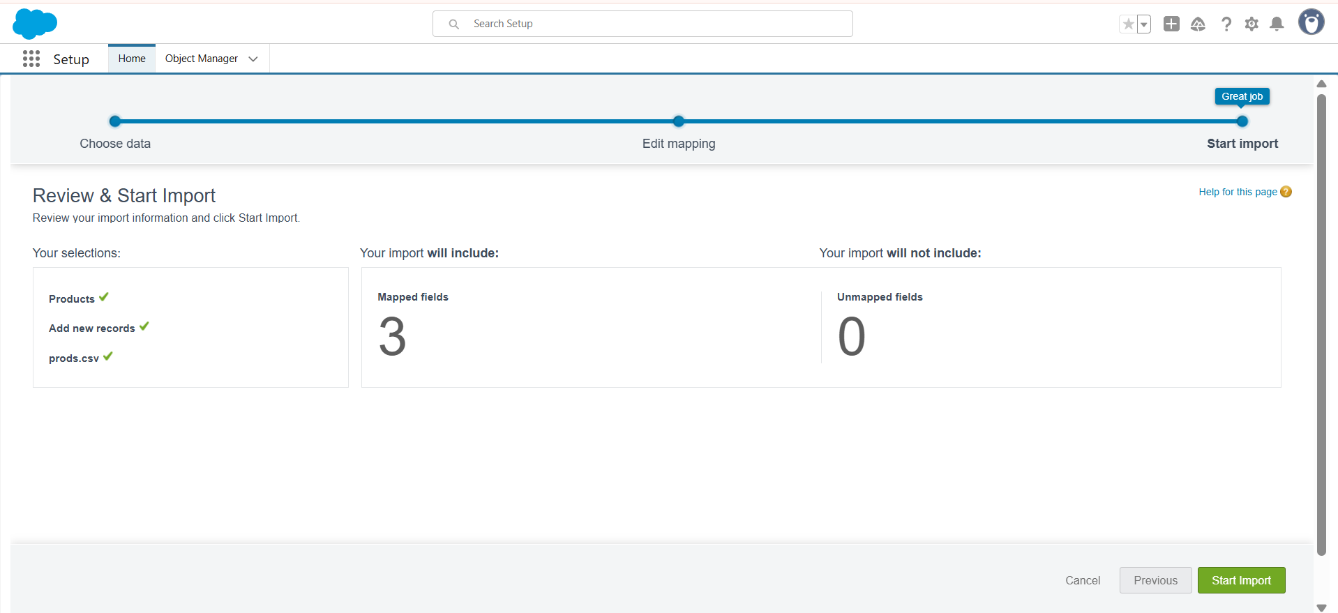

Review and Start Import
- Review the summary of the import.
- Click Start Import.

Monitor Import Progress
- The wizard displays a progress bar for the import.
- Once complete, click View Result.
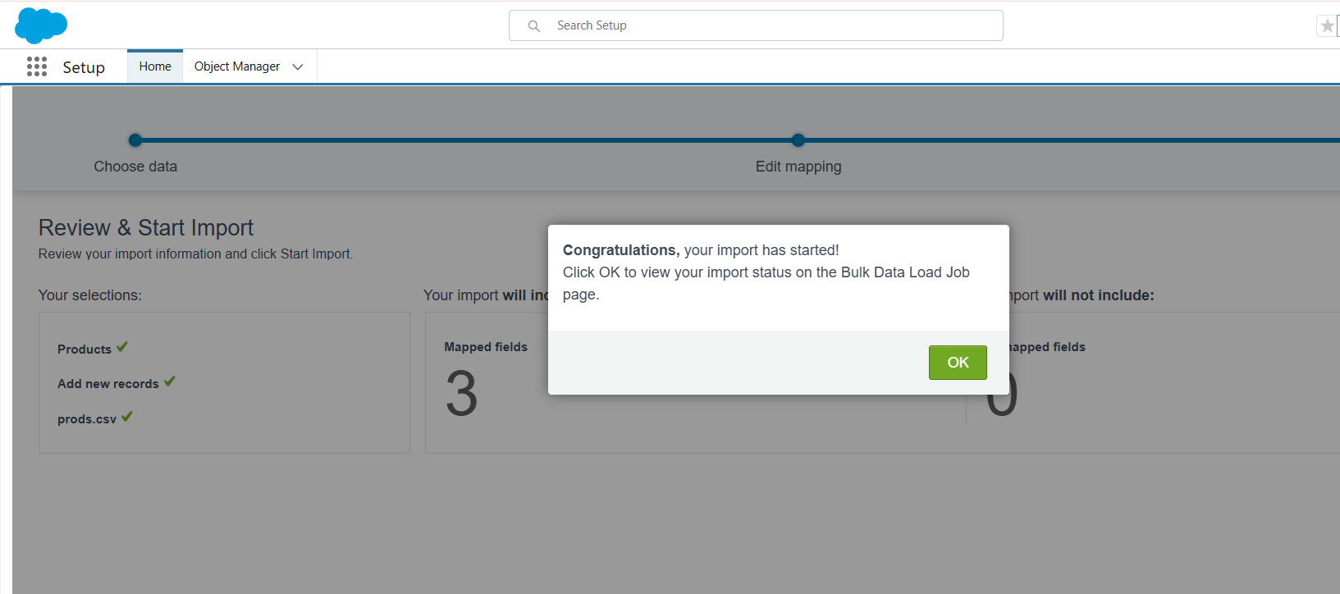

Verify Imported Data
- Navigate to App Launcher → Products.
- Confirm that all product records are created with correct Name, SKU, Price, and Description.
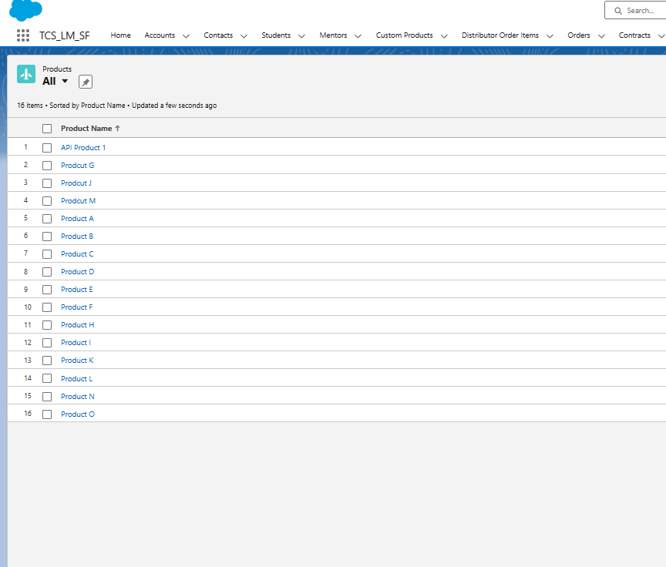

2. Apex Metadata Deployment Using VS Code & SFDX
Steps Completed:
- Opened VS Code in Salesforce project folder.
- Verified connection to DevOrg using sf login org.
- Deployed Apex classes:
sf deploy metadata --metadata ApexClass --target-org DevOrg --wait 10
- Deployment logs showed created and unchanged classes, e.g.:
State | Name | Type
Created | PartnerOrderService | ApexClass
Created | PartnerProductService | ApexClass
Unchanged | OrderService | ApexClass
- Verified deployment success in Setup → Apex Classes in DevOrg.

3. Creating Test Data via Execute Anonymous
Steps Completed:
- Created createTestData.apex script in scripts/ folder:
// create test data for integration testing
Account a = new Account(Name='Distributor Test');
insert a;

Product__c p = new Product__c(Name='API Product 1', SKU__c='API-SKU-1', Price__c=150, Active__c=true);
insert p;

Inventory__c inv = new Inventory__c(Product__c = p.Id, QuantityAvailable__c = 20);
insert inv;

System.debug('DIST:'+a.Id+' PROD:'+p.Id);
- Executed the script using:
sf apex run --target-org DevOrg --file scripts/createTestData.apex
- Confirmed that Accounts, Products, and Inventory records were created in DevOrg.
- Checked debug logs for correct record IDs:
DIST: 001gL00000P8auLQAR
PROD: a07gL00000EiBURQA3

4. Validation of Records
- Queried records to confirm existence:
sf data query --query "SELECT Id, Name FROM Account WHERE Name='Distributor Test'" --target-org DevOrg
sf data query --query "SELECT Id, Name FROM Product__c WHERE Name='API Product 1'" --target-org DevOrg
- Verified IDs match debug logs and can be used for API testing.
Screenshot Suggestions:
- Terminal output showing queried record IDs.

5. Preparing for REST API Testing (Preliminary)
- Used created test data for PartnerOrderService REST API testing.
- JSON payload sample:
{
"distributorId": "001gL00000P8auLQAR",
"items": [
{ "productId": "a07gL00000EiBURQA3", "quantity": 5 }
]
}
- Verified that executing Apex REST service returns 201 Created with newly created Partner Order ID.
Screenshot Suggestions:
- Postman / Workbench showing REST API request and response.
- JSON payload with highlighted IDs.

6. Outcome of Phase 8 (Completed So Far)
- Successfully deployed Apex classes via VS Code & SFDX.
- Created test data for accounts, products, and inventory.
- Queried and verified data in DevOrg.
- Prepared JSON payloads for REST API testing.

